Case studies – big run 1
Dodgy calculator calls in 2016 - 1 H DOSY NMR Determination of the Molecular Weight and the Solution Properties of Poly-( N -acryloylmorpholine) in Various Solvents
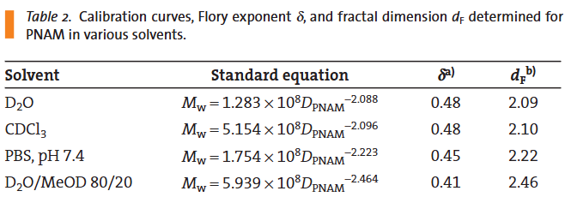
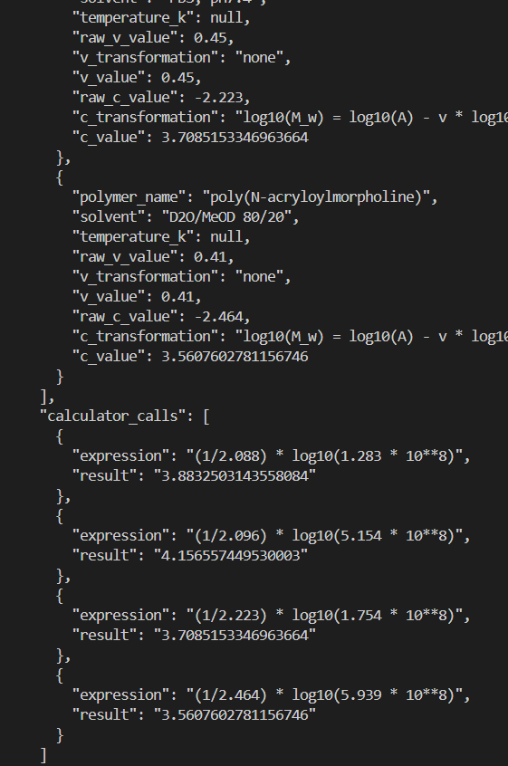

2019 - Quantitative Studies of Block Copolymers and Their Containing Homopolymer Components by Diffusion Ordered Spectroscopy
Failed to provide v value as negative.
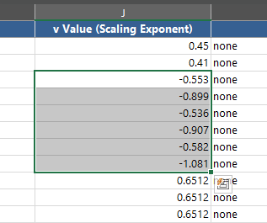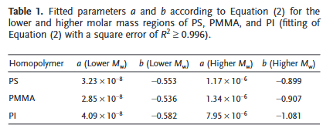
Fix: Added
“CRITICAL: Please be aware that the equation above has the minus sign built in, meaning we ALWAYS
expect the v value to be positive. Make sure the v value you return is always positive by making the appropriate transformation.
“ - Similarly, we expect the returned v value to ALWAYS be positive. Sometimes the diffusion equation being used may not have -v built in, so be aware of this.”
To prompt (Commit “Added -v checks”)

2023 - A fast and efficient way of obtaining the average molecular weight of block copolymers via DOSY
Apparent hallucination in this paper table 8 (and 7)

Categorisation result (table 8):
{
"contains_scientific_data": true,
"contains_raw_diffusion_data": false,
"contains_mark_houwink_parameters": false,
"contains_flory_parameters": true,
"contains_polymer_diffusion_coeff": false
}
Categorisation result (table 7):
{
"contains_scientific_data": true,
"contains_raw_diffusion_data": false,
"contains_mark_houwink_parameters": false,
"contains_flory_parameters": true,
"contains_polymer_diffusion_coeff": false
}

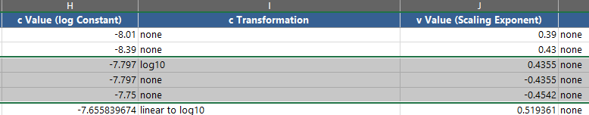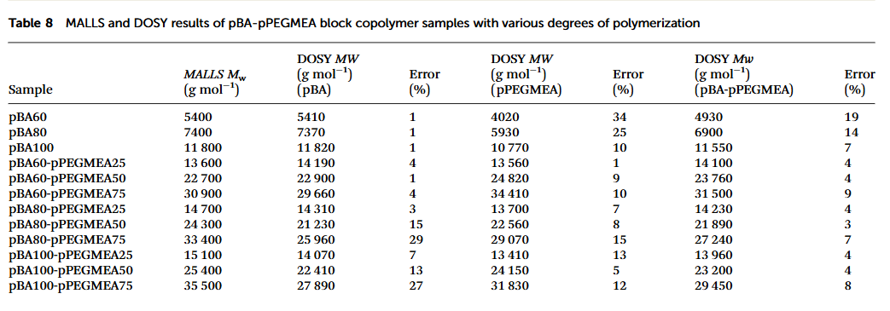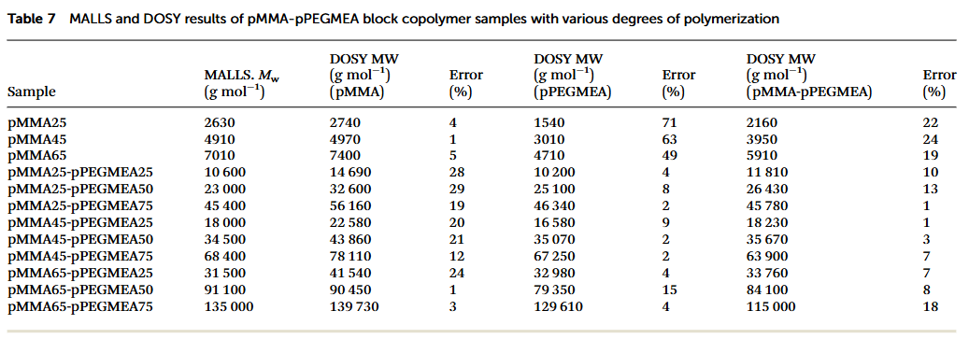
2015 - Determination of the parameters of molecular-weight distribution of hydroxyethyl starches by diffusion-ordered NMR spectroscopy
Incorrect interpretation of table with in-built diffusion equation. Hallucination of chemical names.
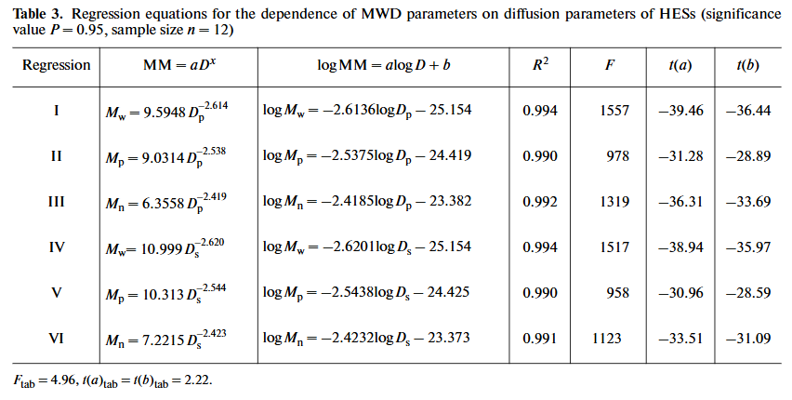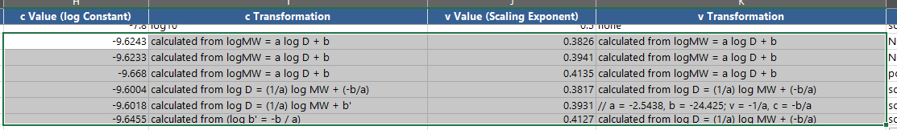
Incorrect calculator use. The c and v value can be extracted directly from these forulae.
{
"contains_scientific_data": true,
"contains_raw_diffusion_data": false,
"contains_mark_houwink_parameters": false,
"contains_flory_parameters": true,
"contains_polymer_diffusion_coeff": true
}

2009 - NMR Measure of Translational Diffusion and Fractal Dimension. Application to Molecular Mass Measurement
Paper does not provide Flory constant term, AI appears to have hallucinated it’s value for all rows

